Syllabus: Music Theory I
Milton Area High School
2007-2008 Second Semester

Mr. Brett Hosterman (bhosterman@miltonsd.org)
Class Location: High School Band Room
Class Time: Period 5 A (11:04 – 11:46am) Daily

Course Description
This course is designed for students who have a desire to learn more about the inner workings of music and harmony and for students intending to major in music in college. Music Theory is a college level class and will require a significant amount of work to be completed outside of class. Homework is necessary to reinforce and practice concepts discussed in class.

Throughout the semester we will spend time discussing the foundations of music, historical background, overview of structure and form, in addition to spending a significant part of the semester learning to analyze and identify harmonic principles of music.

Course Objectives

Students will:

- Develop a greater appreciation for music.
- Identify and define the four basic principles of music.
- Develop a greater understanding of the physics of sound.
- Demonstrate skills in identifying intervals, scales, chord types, cadences, non-chord tones, and choral professions.
- Develop proper skills in four part writing
- Develop skills in music/choral analysis.

Required Materials
- Three Ring Binder or a notebook and folder
- Book Excerpt: This is Your Brain on Music. Daniel J. Levitin. Chapter 2 – “Foot Tapping.” Pages 57-75.
- Notebook paper (staff paper and paper with a keyboard will be provided)
- PENCIL (not a pen)
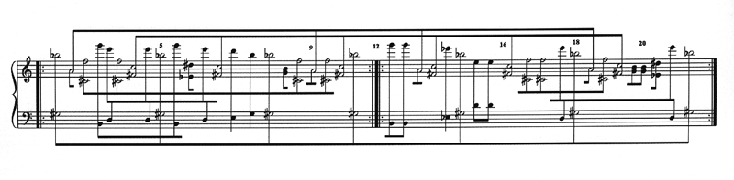
Assignments/Tests & Quizzes:

1. Paper - “What is Music?” (50 Points)
A. Paper should be two pages, double spaced, 12 pt. font
B. This is an open ended prompt. Be Creative and original.
C. Do not look up a definition. There is no right or wrong response.
D. Grade for this assignment will depend on:
- Completion and submitted by due date.
- How well you defend your argument.

- Nightly Homework (5 points each – Averaged into a 150 point HW Grade)
  - Due at the BEGINNING of class the following day.
  - Assignments should be completed in PENCIL (not pen).

- Weekly Quiz (25 points each x 16 weeks = 400 total points)
A. Quizzes will be given on most Fridays.
B. Based on homework and class material from the week.

- Mid-Term Exam (100 Points)
  - Given the last week of the Third Marking Period.
  - Written exam based on Materials from the third marking period.

- Final Written Exam (75 Points)
  - Given the last week of regular classes.
  - Written exam based on Materials from the entire semester.

- Final Project (50 Points)
  - 16 measure 4-part composition with analysis.
  - Proper voice leading.
  - Appropriate choral progressions.
  - Correct use of Non-Chord Tones.
  - A, A1, B, A Form.
  - Proper use of Cadences.

7. Class Participation (75 Points)

Grading Summary: 900 possible points divided by 9 =

A – 100 – 90
B – 89 – 81
C – 80 – 76
D – 75 – 66
F – 65 and below

Weekly Calendar - Topics Covered

3rd Marking Period

Week 1 Principles of Music / Physics of Sound

Week 2 Staffs / Clefs / Pitches

Week 3 Rhythm and Meter

Week 4 Intervals and Scales

Week 5 Major and Minor Scales

Week 6 Triads and Seventh Chords - Inversions

Week 7 Roman Numeral Analysis / Principles of Voice Leading

Week 8 Root Position Part Writing

Week 9 Review – Mid Term

4th Marking Period

Week 1 Form

Week 2 Bach Chorales

Week 3 Chord Progressions

Week 4 Cadences, Phrases, and Periods

Week 5 Non – Chord Tones

Week 6 Analyzing Bach Chorales / Figured Base

Week 7 Modulations (begin final project)

Week 8 Introduction to 20th Century Music

Week 9 Review / Final Exam

**This Calendar will serve as a general outline for the course. Depending on the class we may progress faster or slower through outlined topics.

